**Experiment-04**

**UML diagrams for Online Banking System**

# 1.Use-Case Diagram

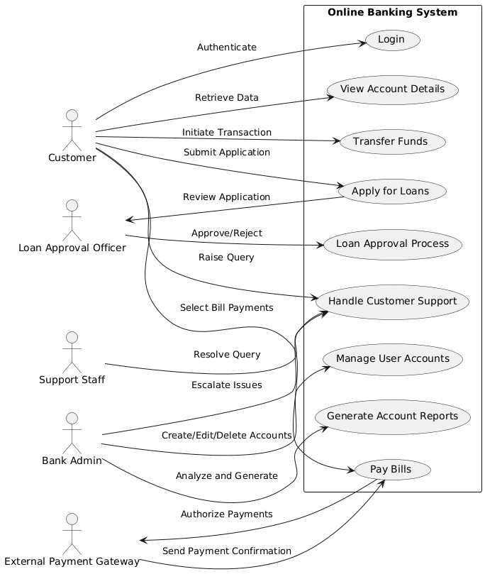

@startuml

left to right direction

skinparam packageStyle rectangle

actor Customer as C

actor "Bank Admin" as BA

actor "External Payment Gateway" as EPG

actor "Loan Approval Officer" as LAO

actor "Support Staff" as SS

rectangle "Online Banking System" {

    (Login) as UC1

    (View Account Details) as UC2

    (Transfer Funds) as UC3

    (Pay Bills) as UC4

    (Apply for Loans) as UC5

    (Loan Approval Process) as UC6

    (Manage User Accounts) as UC7

    (Generate Account Reports) as UC8

    (Handle Customer Support) as UC9

}

' Customer Use Cases

C --> UC1 : "Authenticate"

C --> UC2 : "Retrieve Data"

C --> UC3 : "Initiate Transaction"

C --> UC4 : "Select Bill Payments"

C --> UC5 : "Submit Application"

C --> UC9 : "Raise Query"

' Admin Use Cases

BA --> UC7 : "Create/Edit/Delete Accounts"

BA --> UC8 : "Analyze and Generate"

BA --> UC9 : "Escalate Issues"

' Payment Gateway Integration

UC4 --> EPG : "Authorize Payments"

EPG --> UC4 : "Send Payment Confirmation"

' Loan Approval Process

UC5 --> LAO : "Review Application"

LAO --> UC6 : "Approve/Reject"

' Support Staff Use Case

SS --> UC9 : "Resolve Query"

@enduml

# 2.Class Diagram

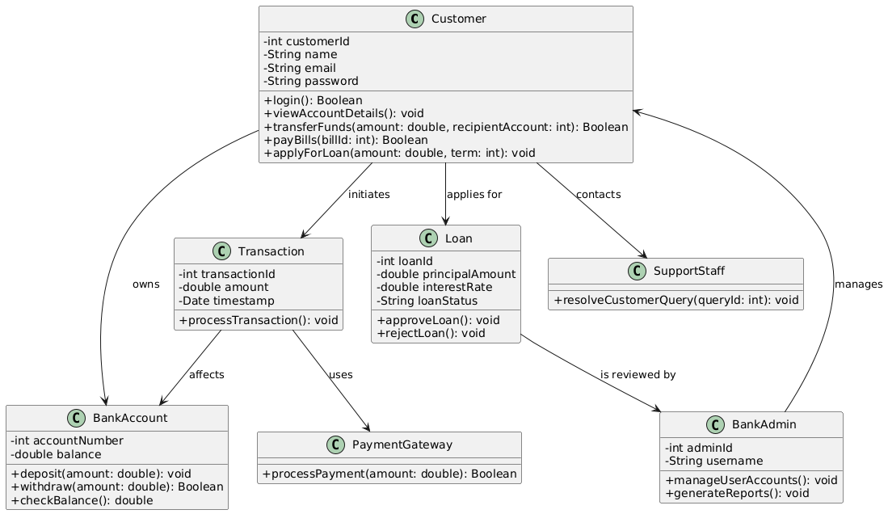

@startuml

' Advanced Class Diagram for Online Banking System

skinparam classAttributeIconSize 0

class Customer {

- int customerId

- String name

- String email

- String password

+ login(): Boolean

+ viewAccountDetails(): void

+ transferFunds(amount: double, recipientAccount: int): Boolean

+ payBills(billId: int): Boolean

+ applyForLoan(amount: double, term: int): void

}

class BankAccount {

- int accountNumber

- double balance

+ deposit(amount: double): void

+ withdraw(amount: double): Boolean

+ checkBalance(): double

}

class Transaction {

- int transactionId

- double amount

- Date timestamp

+ processTransaction(): void

}

class Loan {

- int loanId

- double principalAmount

- double interestRate

- String loanStatus

+ approveLoan(): void

+ rejectLoan(): void

}

class BankAdmin {

- int adminId

- String username

+ manageUserAccounts(): void

+ generateReports(): void

}

class PaymentGateway {

+ processPayment(amount: double): Boolean

}

class SupportStaff {

+ resolveCustomerQuery(queryId: int): void

}

Customer --> BankAccount : "owns"

Customer --> Transaction : "initiates"

Customer --> Loan : "applies for"

Customer --> SupportStaff : "contacts"

Transaction --> BankAccount : "affects"

BankAdmin --> Customer : "manages"

Loan --> BankAdmin : "is reviewed by"

Transaction --> PaymentGateway : "uses"

@enduml

# 3.Sequence Diagram

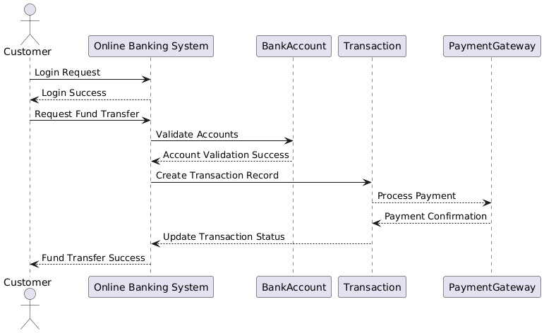

@startuml

' Advanced Sequence Diagram for Fund Transfer

actor Customer

participant "Online Banking System" as OBS

participant BankAccount

participant Transaction

participant PaymentGateway

Customer -> OBS: Login Request

OBS --> Customer: Login Success

Customer -> OBS: Request Fund Transfer

OBS -> BankAccount: Validate Accounts

BankAccount --> OBS: Account Validation Success

OBS -> Transaction: Create Transaction Record

Transaction --> PaymentGateway: Process Payment

PaymentGateway --> Transaction: Payment Confirmation

Transaction --> OBS: Update Transaction Status

OBS --> Customer: Fund Transfer Success

@enduml

# 4. Collaboration Diagram

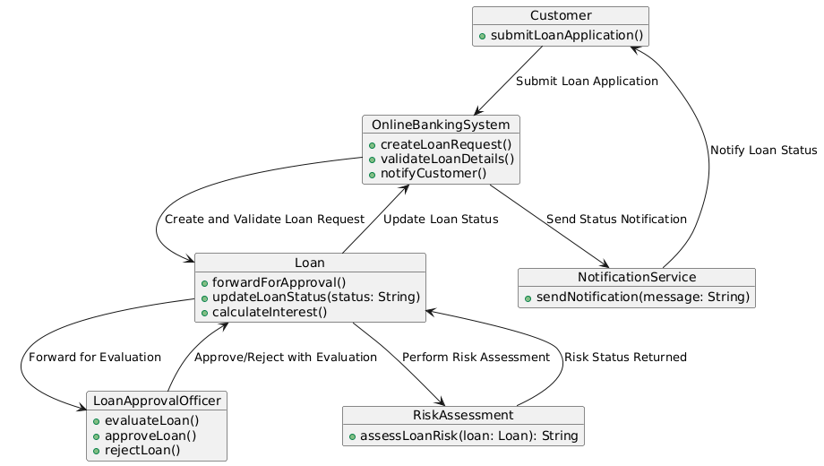

@startuml

' Enhanced Collaboration Diagram for Loan Application with Extended Functionality

object Customer {

+ submitLoanApplication()

}

object OnlineBankingSystem {

+ createLoanRequest()

+ validateLoanDetails()

+ notifyCustomer()

}

object Loan {

+ forwardForApproval()

+ updateLoanStatus(status: String)

+ calculateInterest()

}

object LoanApprovalOfficer {

+ evaluateLoan()

+ approveLoan()

+ rejectLoan()

}

object RiskAssessment {

+ assessLoanRisk(loan: Loan): String

}

object NotificationService {

+ sendNotification(message: String)

}

Customer --> OnlineBankingSystem : "Submit Loan Application"

OnlineBankingSystem --> Loan : "Create and Validate Loan Request"

Loan --> RiskAssessment : "Perform Risk Assessment"

RiskAssessment --> Loan : "Risk Status Returned"

Loan --> LoanApprovalOfficer : "Forward for Evaluation"

LoanApprovalOfficer --> Loan : "Approve/Reject with Evaluation"

Loan --> OnlineBankingSystem : "Update Loan Status"

OnlineBankingSystem --> NotificationService : "Send Status Notification"

NotificationService --> Customer : "Notify Loan Status"

@enduml

# 5. State-Chart Diagram

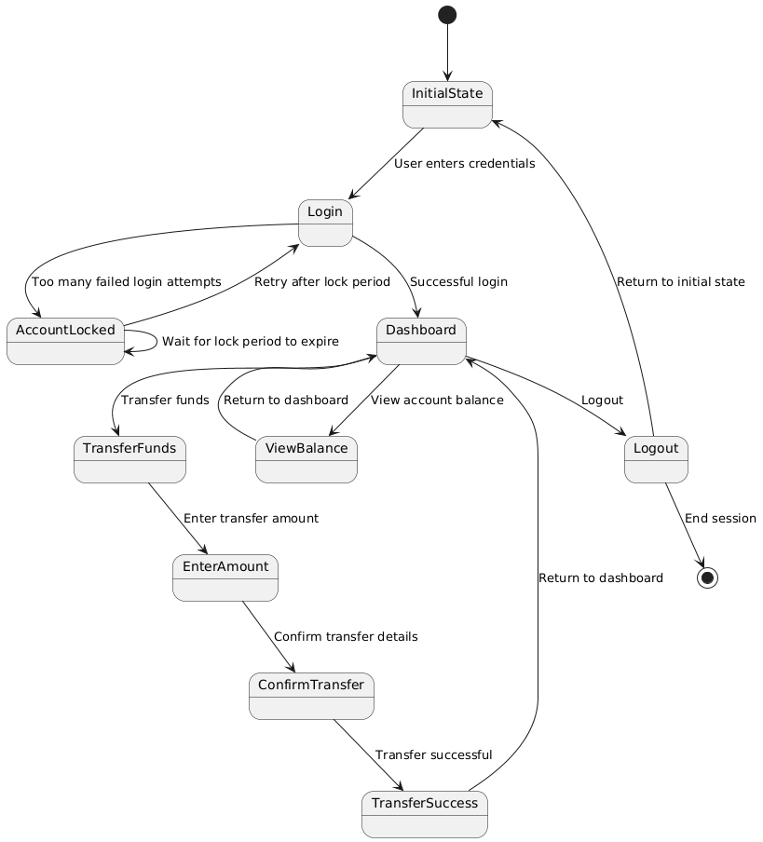

@startuml

[*] --> InitialState

InitialState --> Login : User enters credentials

Login --> Dashboard : Successful login

Login --> AccountLocked : Too many failed login attempts

AccountLocked --> AccountLocked : Wait for lock period to expire

AccountLocked --> Login : Retry after lock period

Dashboard --> ViewBalance : View account balance

Dashboard --> TransferFunds : Transfer funds

Dashboard --> Logout : Logout

ViewBalance --> Dashboard : Return to dashboard

TransferFunds --> EnterAmount : Enter transfer amount

EnterAmount --> ConfirmTransfer : Confirm transfer details

ConfirmTransfer --> TransferSuccess : Transfer successful

TransferSuccess --> Dashboard : Return to dashboard

Logout --> InitialState : Return to initial state

Logout --> [*] : End session

@enduml

# 6. Activity Diagram

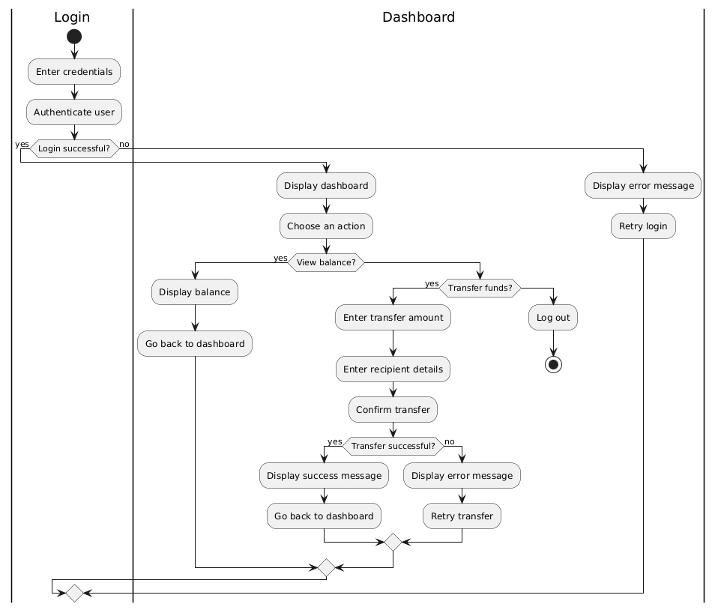

@startuml

|Login|

start

:Enter credentials;

:Authenticate user;

if (Login successful?) then (yes)

|Dashboard|

:Display dashboard;

:Choose an action;

if (View balance?) then (yes)

:Display balance;

:Go back to dashboard;

else

if (Transfer funds?) then (yes)

:Enter transfer amount;

:Enter recipient details;

:Confirm transfer;

if (Transfer successful?) then (yes)

:Display success message;

:Go back to dashboard;

else (no)

:Display error message;

:Retry transfer;

endif

else

:Log out;

stop

endif

endif

else (no)

:Display error message;

:Retry login;

endif

@enduml

# 7. Component Diagram

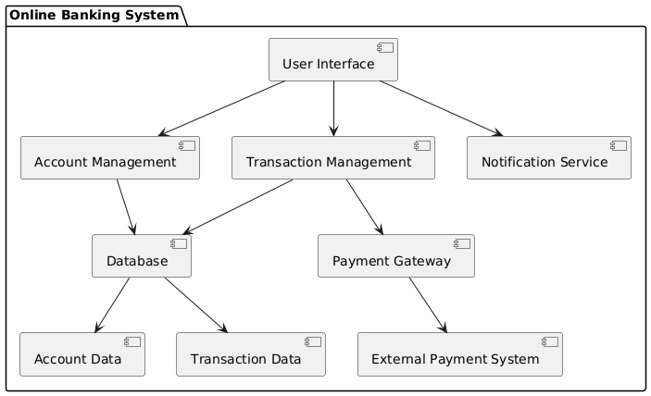

@startuml

package "Online Banking System" {

[User Interface] -down-> [Account Management]

[User Interface] -down-> [Transaction Management]

[User Interface] -down-> [Notification Service]

[Account Management] -down-> [Database]

[Transaction Management] -down-> [Payment Gateway]

[Transaction Management] -down-> [Database]

[Database] --> [Account Data]

[Database] --> [Transaction Data]

[Payment Gateway] --> [External Payment System]

}

@enduml

# 8. Deployment Diagram

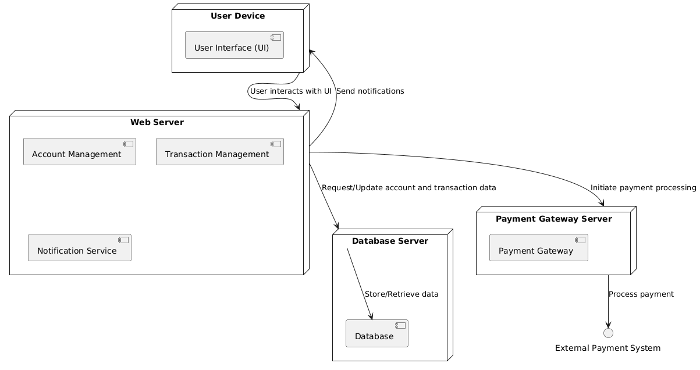

@startuml

node "User Device" {

component "User Interface (UI)"

}

node "Web Server" {

component "Account Management"

component "Transaction Management"

component "Notification Service"

}

node "Database Server" {

component "Database"

}

node "Payment Gateway Server" {

component "Payment Gateway"

}

"User Device" --> "Web Server" : User interacts with UI

"Web Server" --> "Database Server" : Request/Update account and transaction data

"Web Server" --> "Payment Gateway Server" : Initiate payment processing

"Web Server" --> "User Device" : Send notifications

"Database Server" --> "Database" : Store/Retrieve data

"Payment Gateway Server" --> "External Payment System" : Process payment

@enduml